Calling all FIU MS-SLP Alumni and our fellow South Florida SLPs!

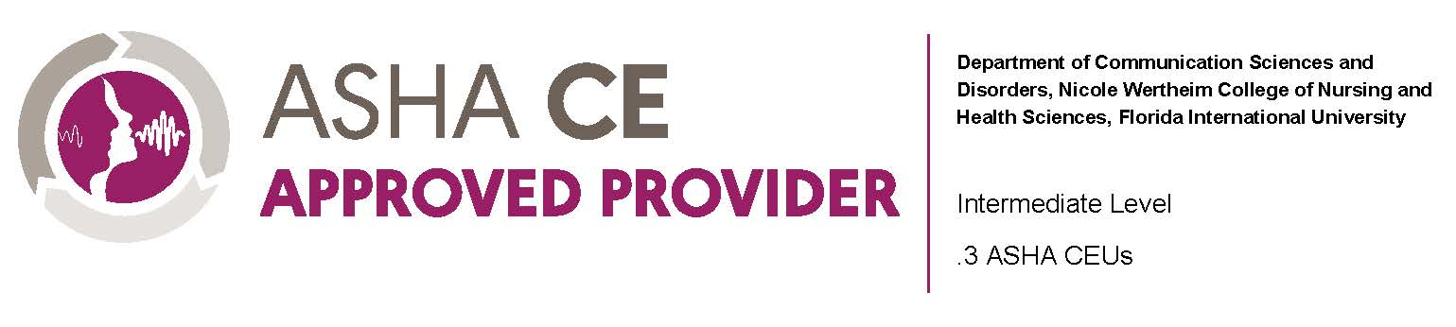

The Department of Communication Sciences & Disorders
at Florida International University
and the National Stuttering Association present:

Stuttering: A Cultural and Linguistic Diversity Perspective

When: Saturday, April 15 | 9AM – 12:45PM

Where: The Graham Center Ballroom
Florida International University, MMC Campus
11200 SW 8 Street
Miami, FL 33199

Earn: .3 ASHA CEUs
To receive ASHA CEUs, you must be in attendance for
the entire event.

Registration Fees:
Learners who want to earn ASHA CEUs: $15.00

Please note, this extra cost is meant to cover FIU’s processing of your
information and is completely separate from the CE Registry Fee you pay to
ASHA Continuing Education
All monies will be donated to FIU Masters’ SLP
student conference scholarships

What: Join us as we host our special guest speaker, Dr. Kia
Noelle Johnson, Associate Director of the Arthur M. Blank Center for Stuttering Education and Research Atlanta Satellite, who will be facilitating our main workshop titled “The Impact of Cultural and Linguistic Diversity on Developmental Stuttering”. We will be wrapping up with a panel discussion led by Dr. Angela Medina in collaboration with the National Stuttering Association’s Miami Chapter.

Learning Outcomes:
After attending this CEU event, participants will be able to:
- Summarize research findings related to cultural and linguistic diversity and stuttering.
- Provide examples of ways in which cultural and linguistic diversity can impact the presentation of core and secondary behaviors of stuttering.
- Describe at least one way in which service-delivery can be adapted to be more culturally responsive.

Course Completion Requirements:
Participants will have successfully completed the course if they attended the 1.5 hour session and the 1 hour 15-minute panel presentation and submitted the ASHA CEU course evaluation form.
Time ordered agenda:
9:00-9:30am Welcoming words

9:30-11:00am The Impact of Cultural and Linguistic Diversity on Developmental Stuttering
Research Summary of stuttering in CLD children
Understanding Cultural Competence and Cultural Humility
Impact of CLD on stuttering
How does cultural and linguistic diversity Impact Stuttering
Bilingual Assessment Considerations
Summary & Questions

11:00-11:15am BREAK

11:15am-12:30pm Miami Chapter Panel Presentation
Introduction of panelists
Topic 1: Finding a support group; barriers and facilitators
Topic 2: The role of stuttering support groups in speech therapy
Topic 3: Personal reflections of support group experience
Audience Q&A

12:30-12:45pm CEU Event Closing Remarks

Financial and Nonfinancial Disclosures
Dr. Kia Noelle Johnson
Financial — Salaried employee of the University of Texas at Austin
Nonfinancial — NBASLH Board of Directors, chair; ASHA Board of Ethics, member

Dr. Angela Medina
Financial — Salaried employee of Florida Int’l University
Nonfinancial — National Stuttering Association, Research Chair and Miami Chapter
Co-Leader

Anabel Augustin
Financial-- None.
Nonfinancial -- Co-Chapter leader of the NSA Miami Chapter. Member of the NSA
We Stutter @ Work Committee.

Aslyn Gonzalez
Financial -- None.
Nonfinancial -- NSA Miami Chapter Member.

Brandon Davis
Financial -- None.
Nonfinancial -- NSA Miami Chapter Member.

Matthew Perez
Financial -- None.
Nonfinancial -- NSA Miami Chapter Member.

We look forward to seeing familiar and new faces at this exciting event!
Please let us know if you need any specific accommodations (medinaam@fiu.edu)

